Talha Khan
IT-481-DL1
2/7/2026

Assignment: Lab 3 – Creating an IAM User

Step 1: Logged into the AWS Console using root email. 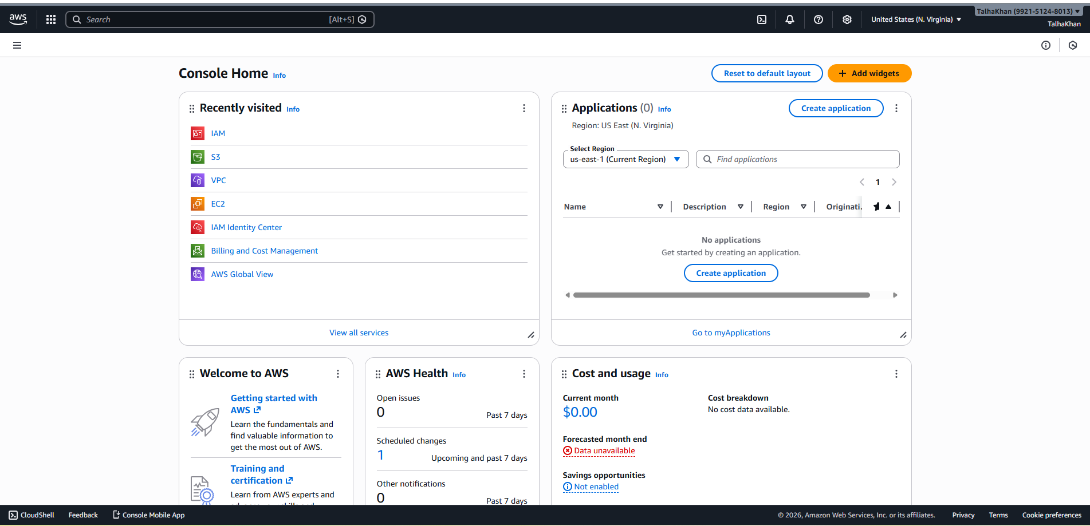
Step 2: In the Search bar at the top of the console, I typed “IAM” and clicked “IAM (Manage Access to AWS resources)”. 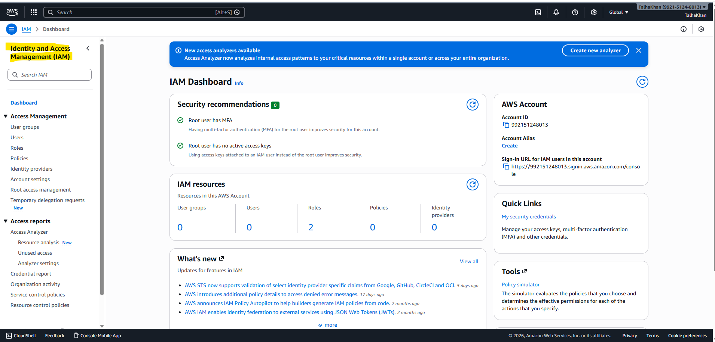
Step 3: On the left-hand menu of the IAM dashboard, I clicked “Users”. 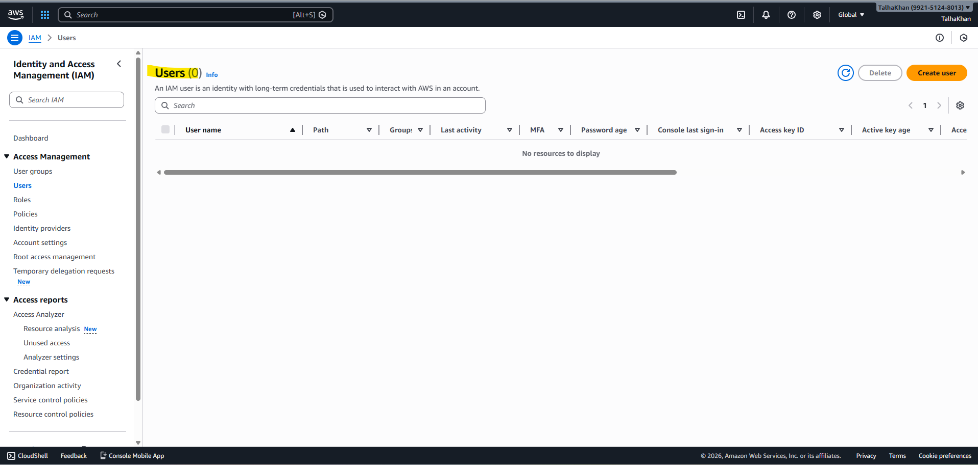
Step 4: After, I clicked the “Create User” button on the users page. 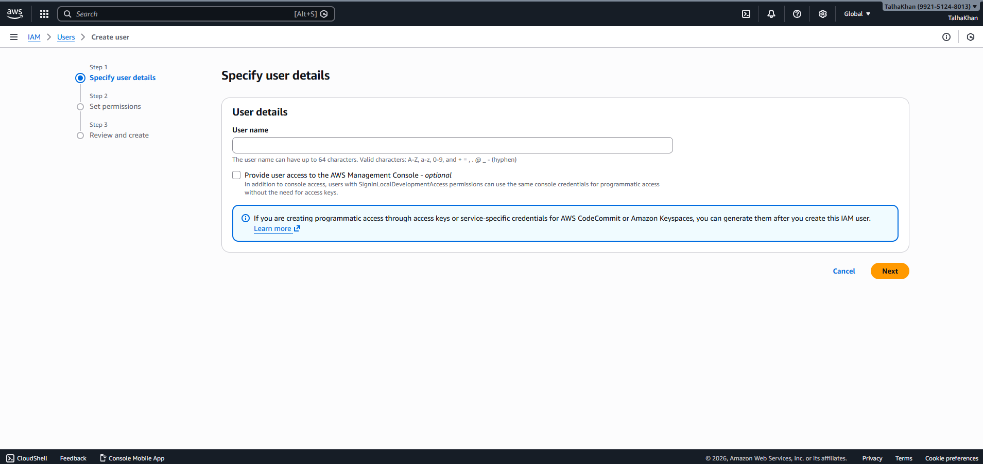
Step 5: Next, I entered the username “it481-user”.
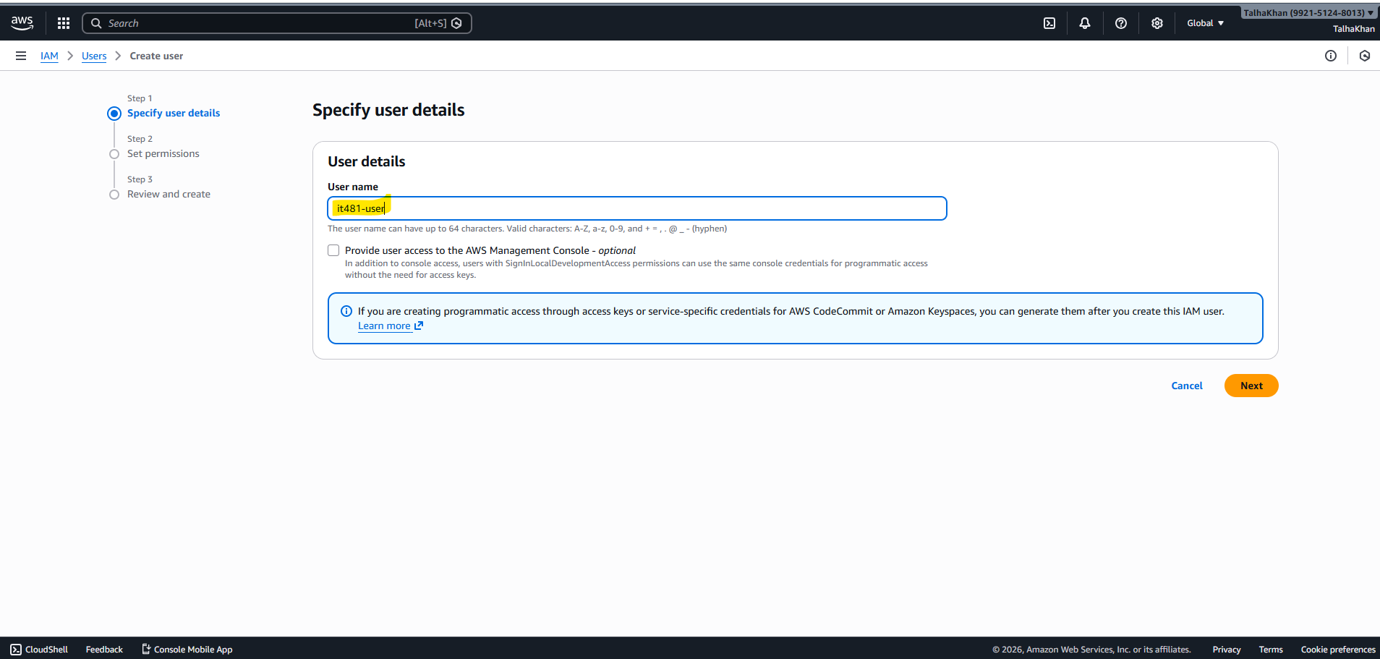
Step 6: After, I checked the box that says, “Provide user access to the AWS Management Console”.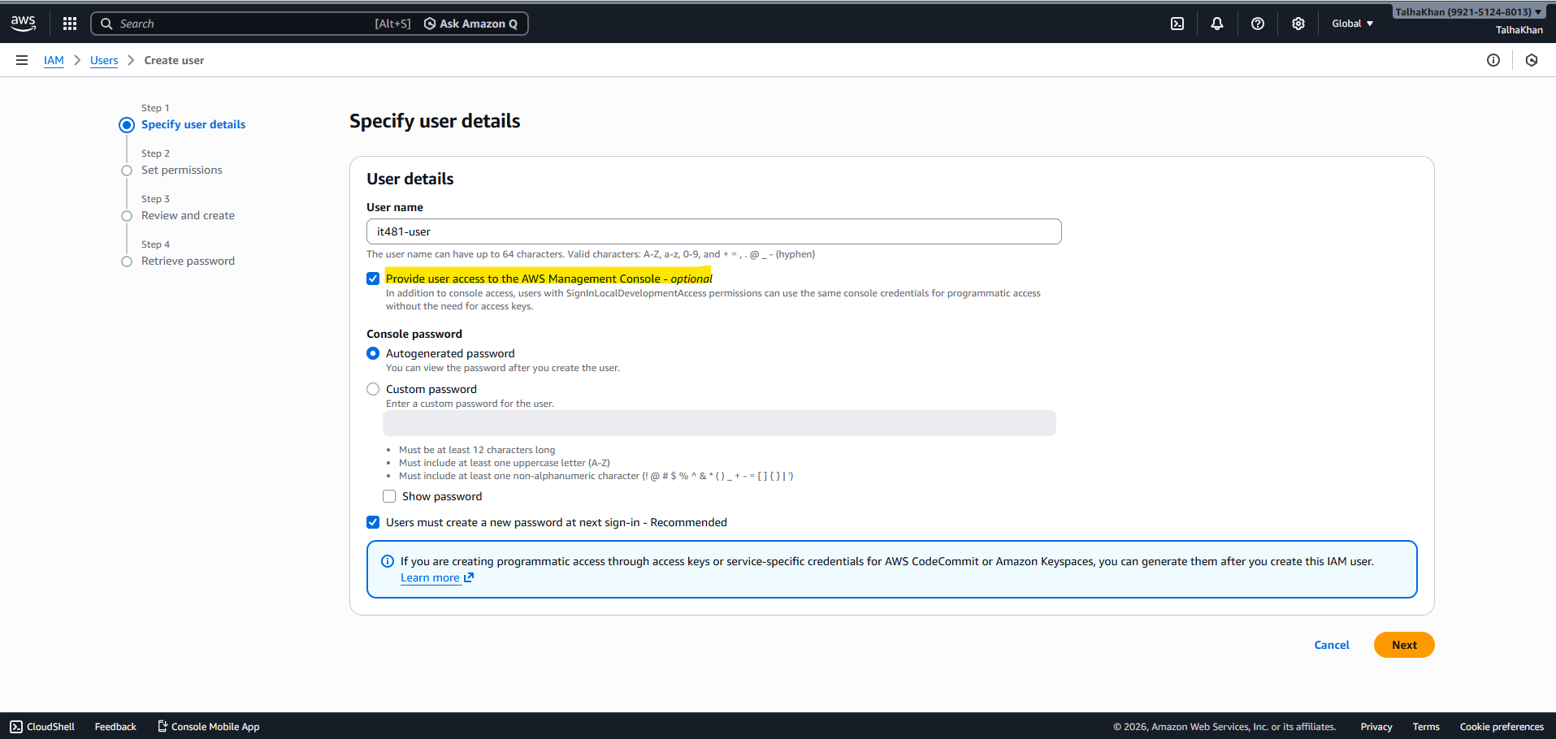
Step 7: Next, I chose the Autogenerated password from the options. 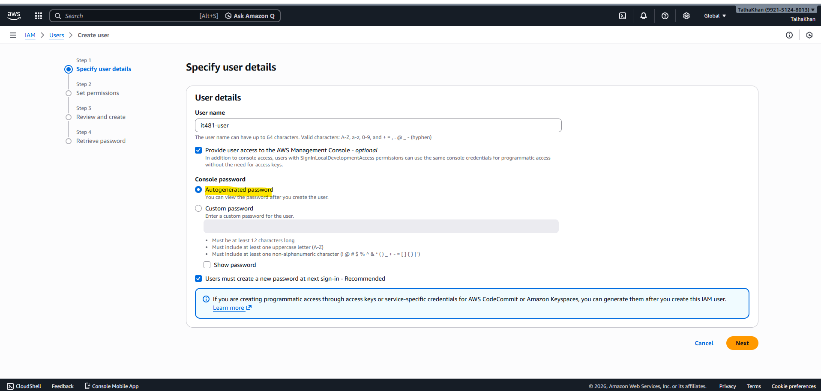
Step 8: After clicking next, under “Set permissions” section, I selected “Attach Policies” directly. 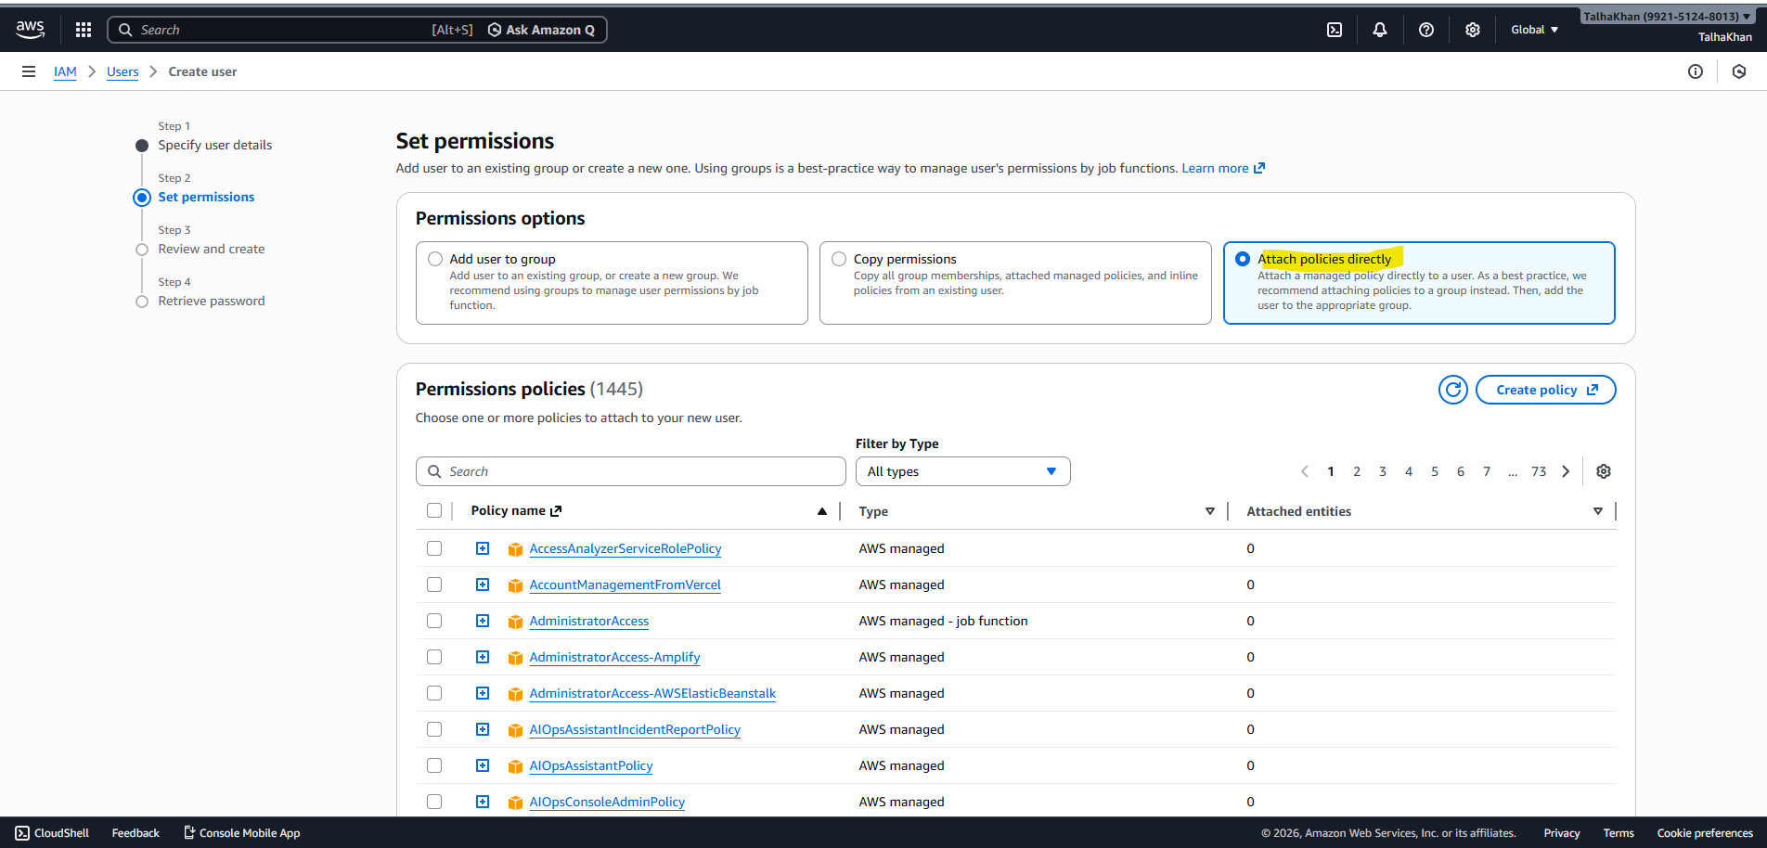
Step 9: From the list of policies, I searched for and selected “ReadOnlyAccess”. 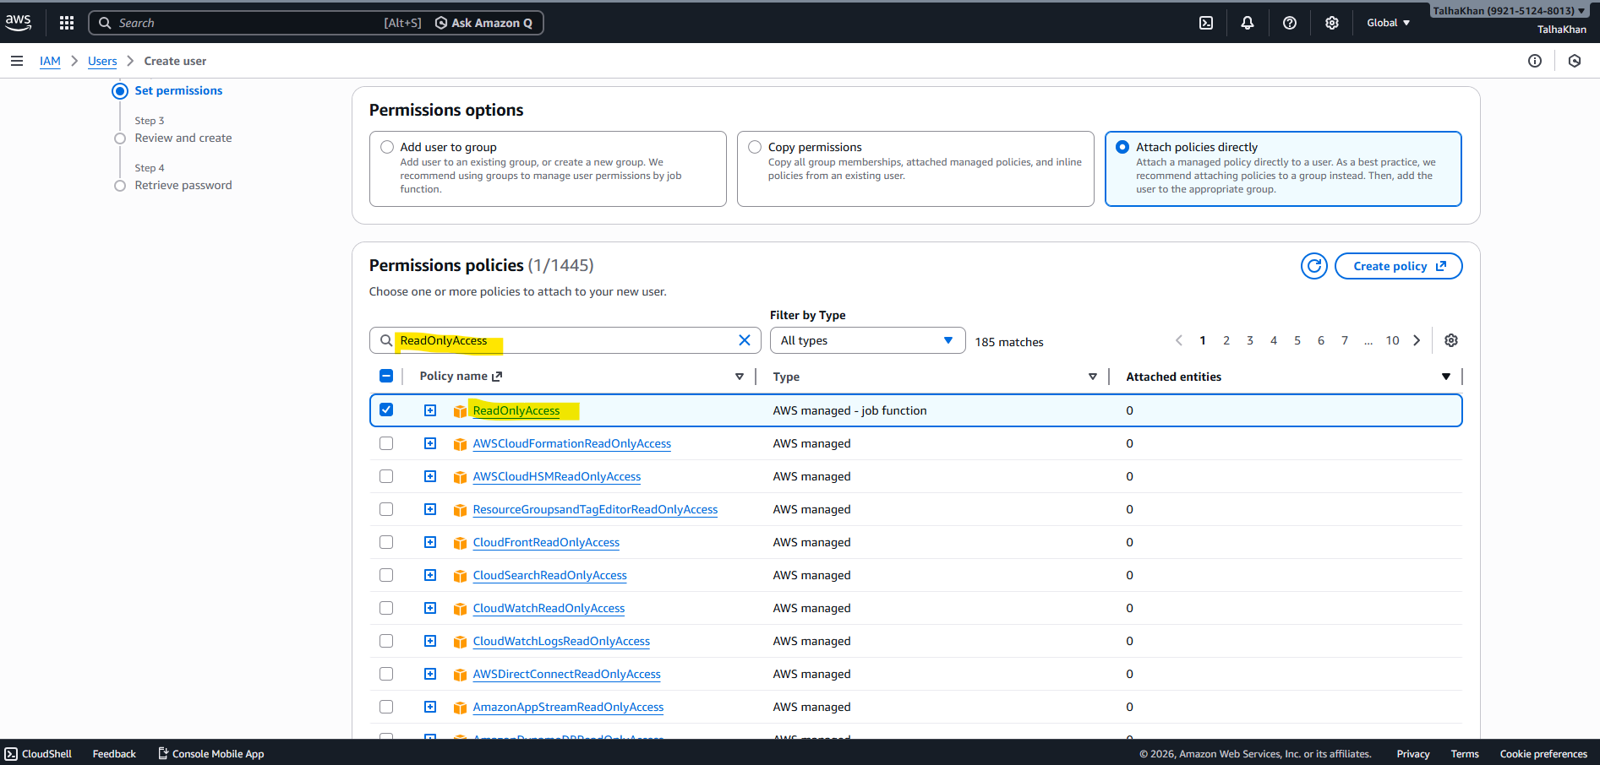
Step 10: After clicking next, I read the details and clicked on “create user”. 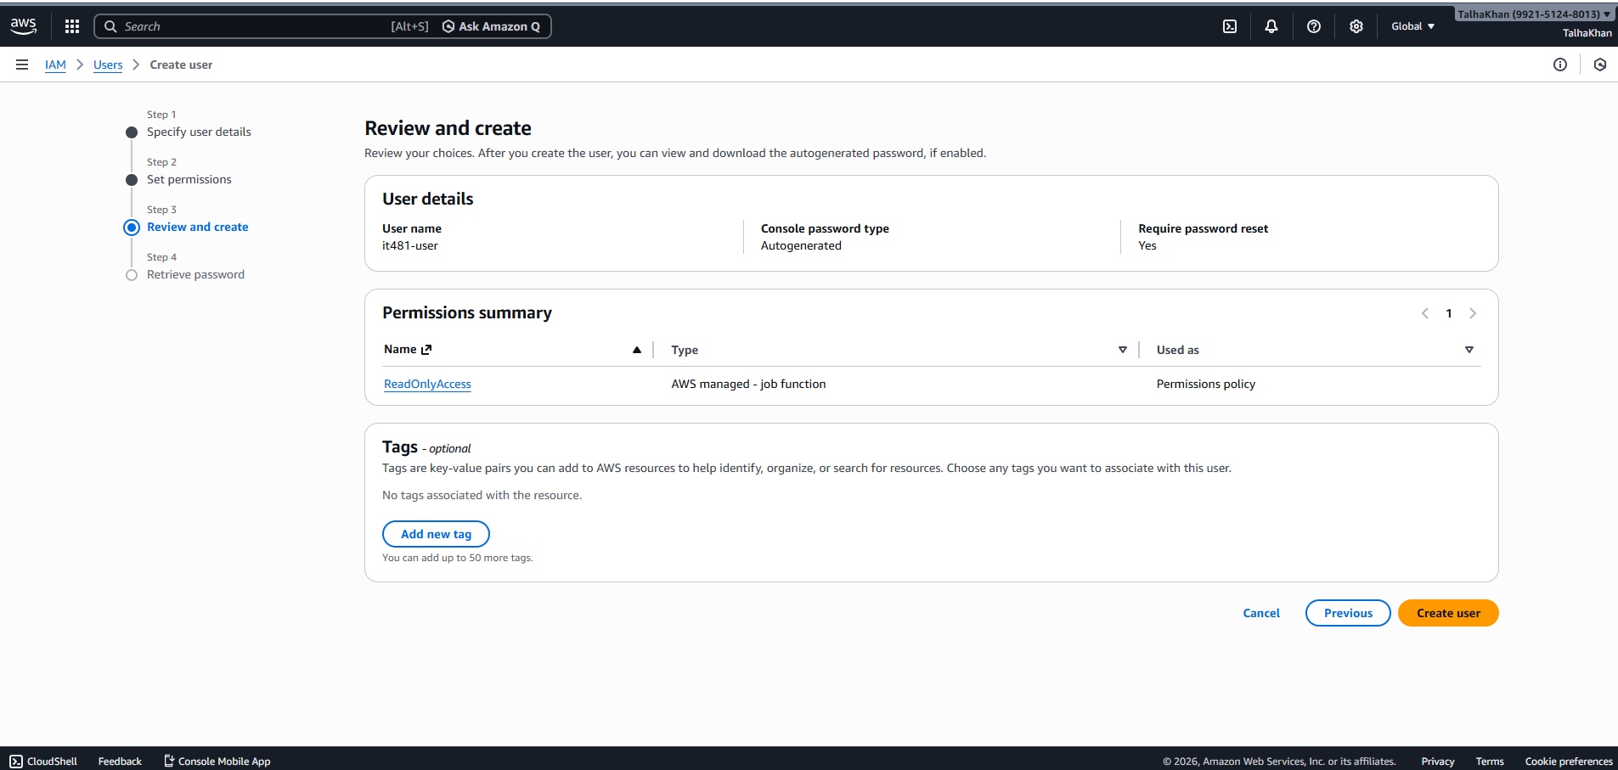
Step 11: After the user was created, the IAM user sign-in URL was shown on the confirmation page.
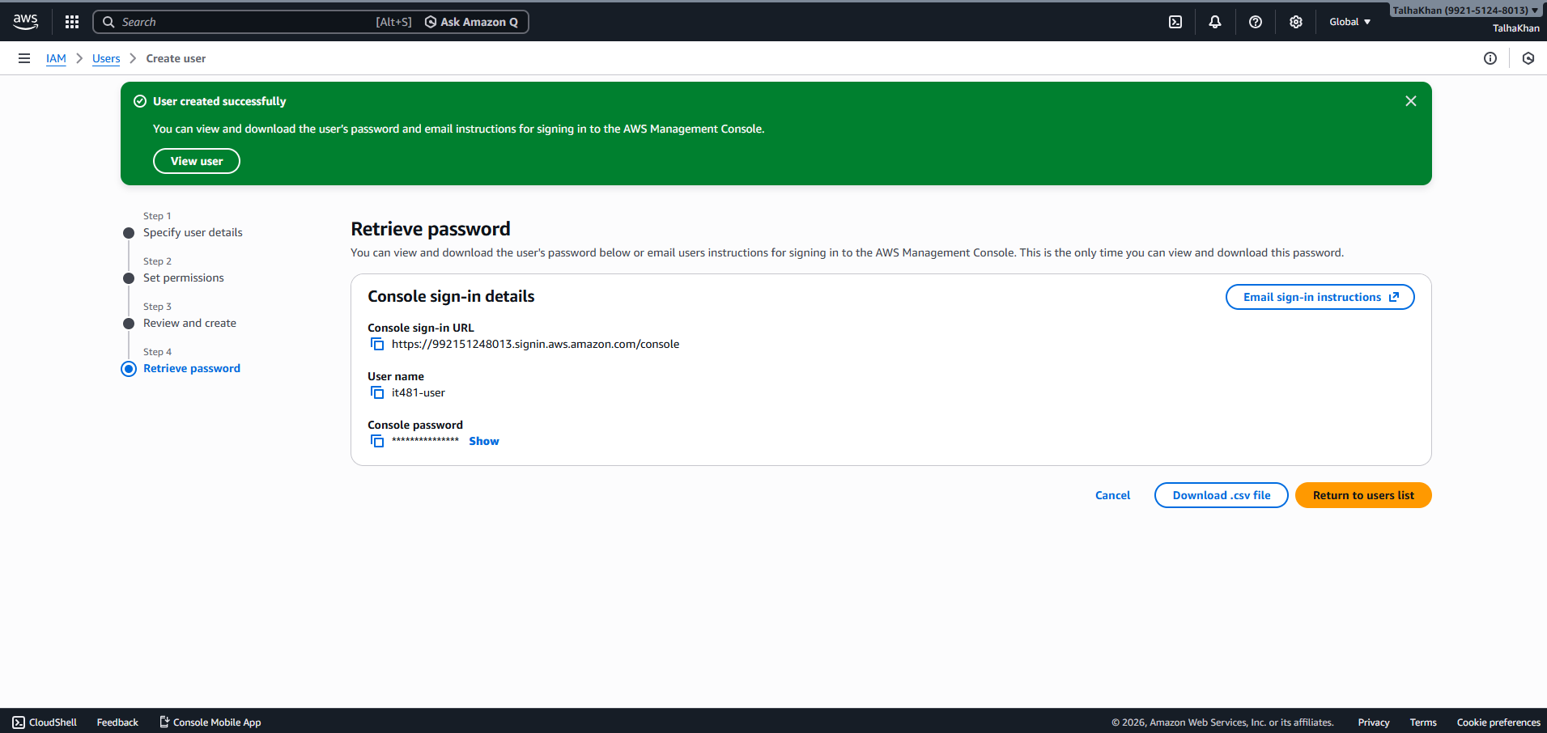
Step 12: Next, I clicked on the newly created user and navigated to the “Security credentials” tab. 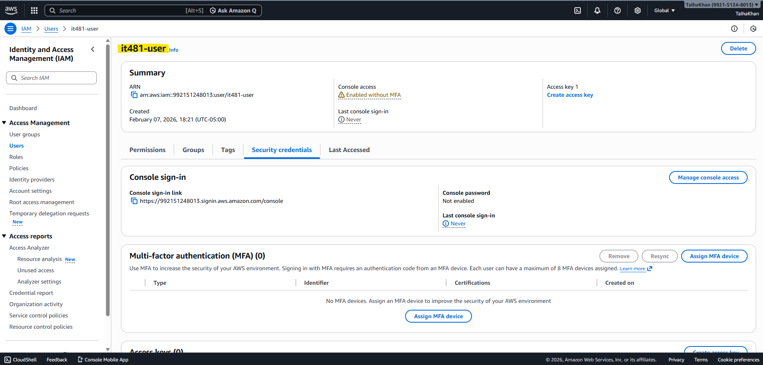
Step 13: Then, I enabled MFA for the IAM user like we did in the Lab 2. 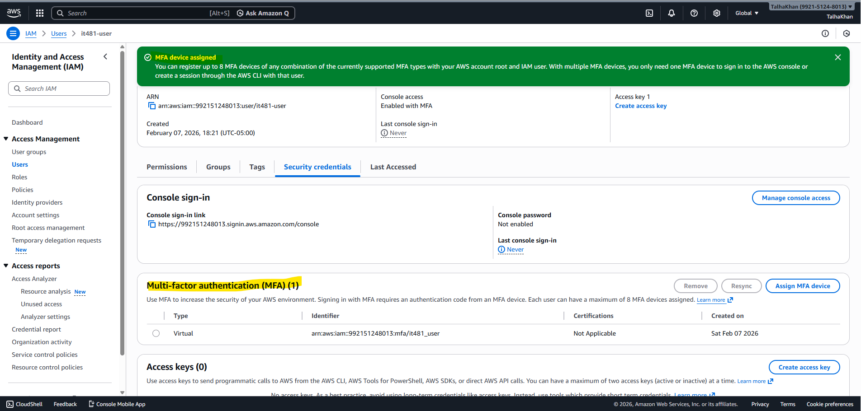
Step 14: I signed out from the root account. 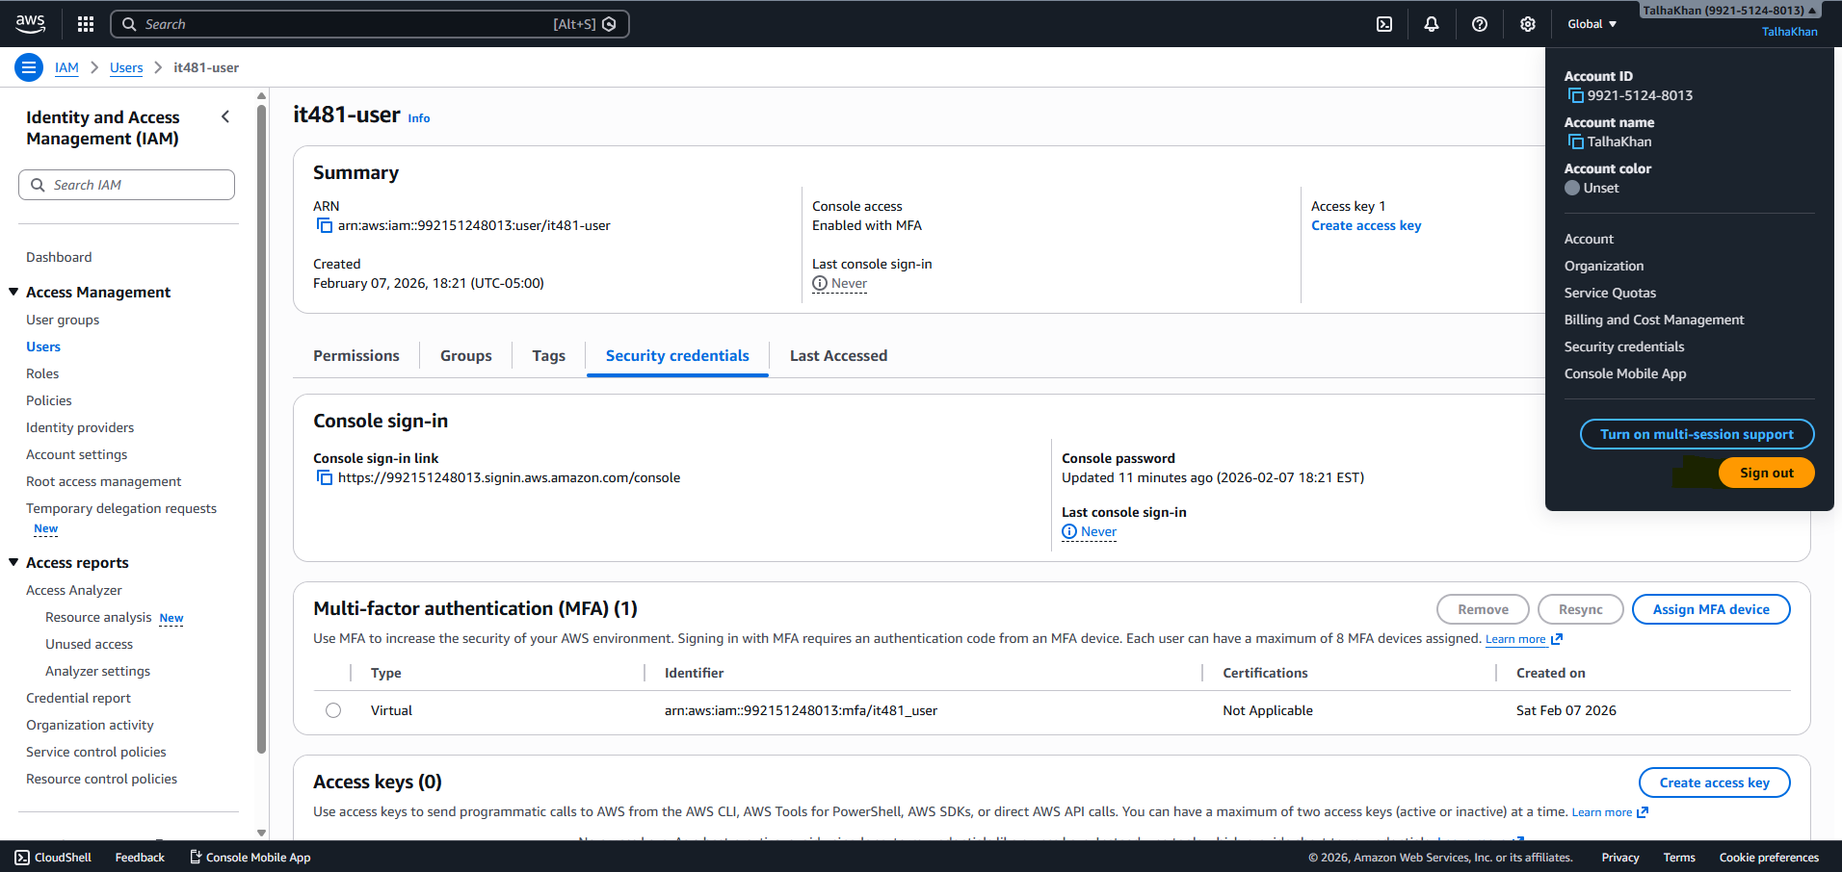
Step 15: In the new browser window, I logged in using the IAM user sign-in URL and the credentials created. 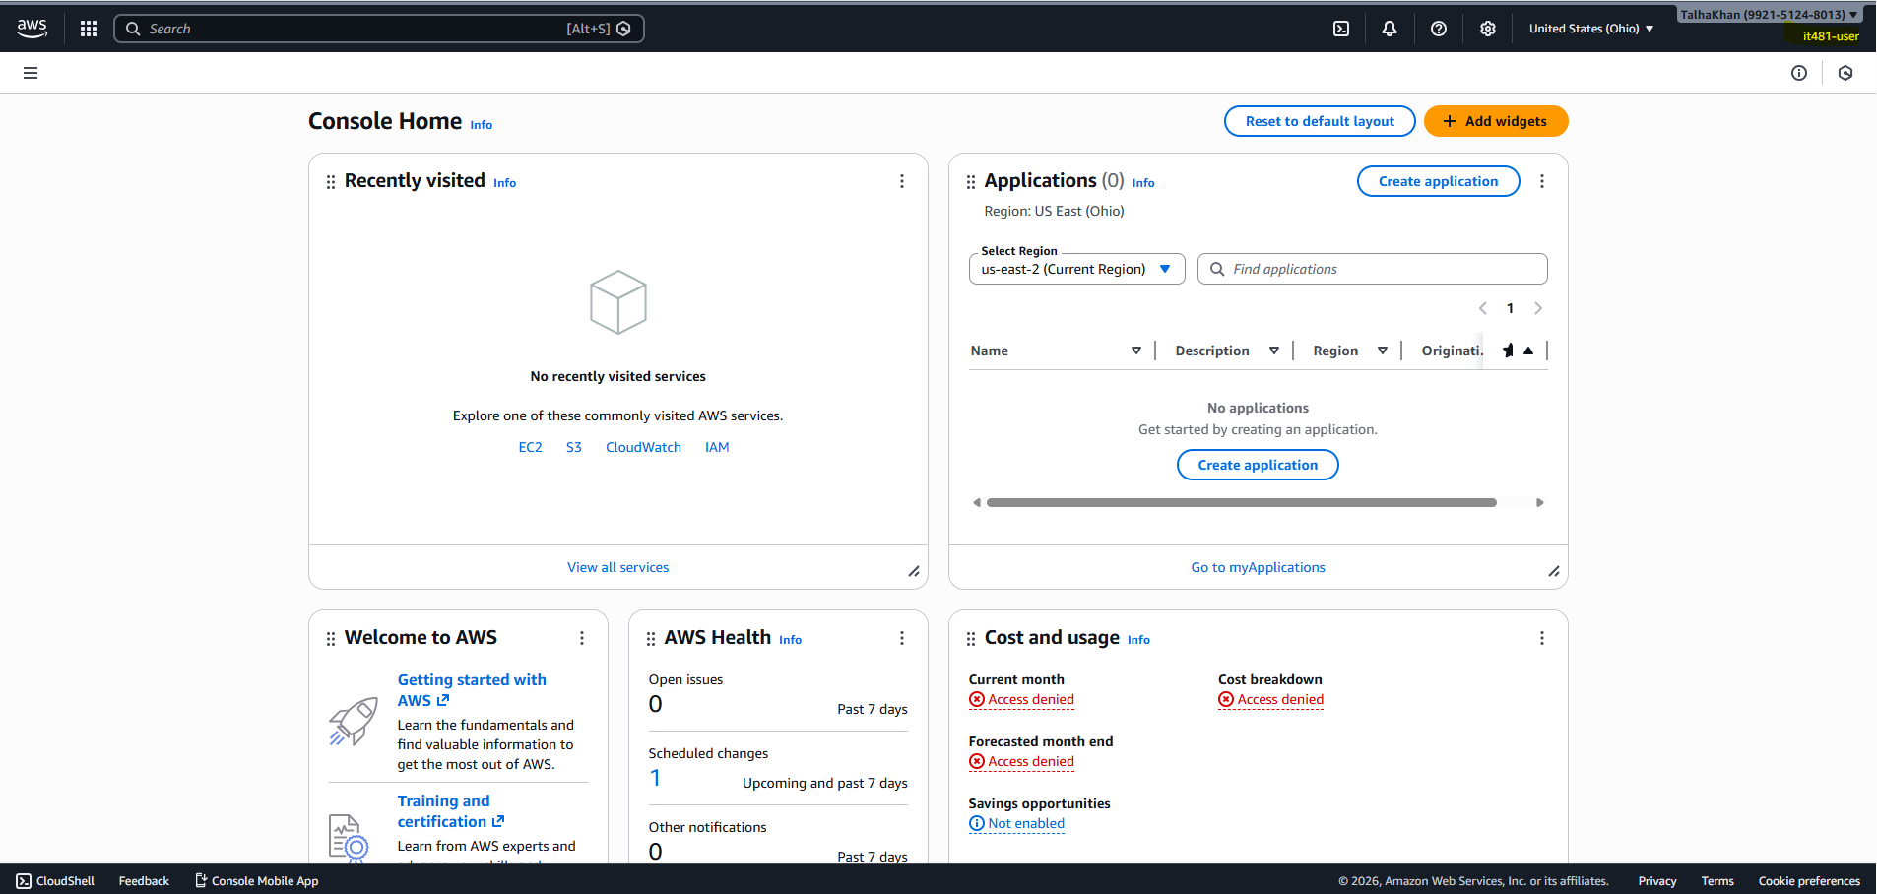
Step 16: Finally, I verified that the IAM user has read only access by trying to create an IAM user. After trying, it gave me an error since we only have the read only access.